COS30018 - Option B - Task 1: Setup

Cody Cronin-Sporys

103610020

# The Process:

The first step was to download the code file (v0.1) and follow along with the tutorial. I already had python setup in vs code so the first problem I came across was importing all the libraries. I read the information on requirements files, so I wrote down all the missing libraries into a text file. I also check the P1 requirements file and added those libraries as well before running pip install requirements.txt.

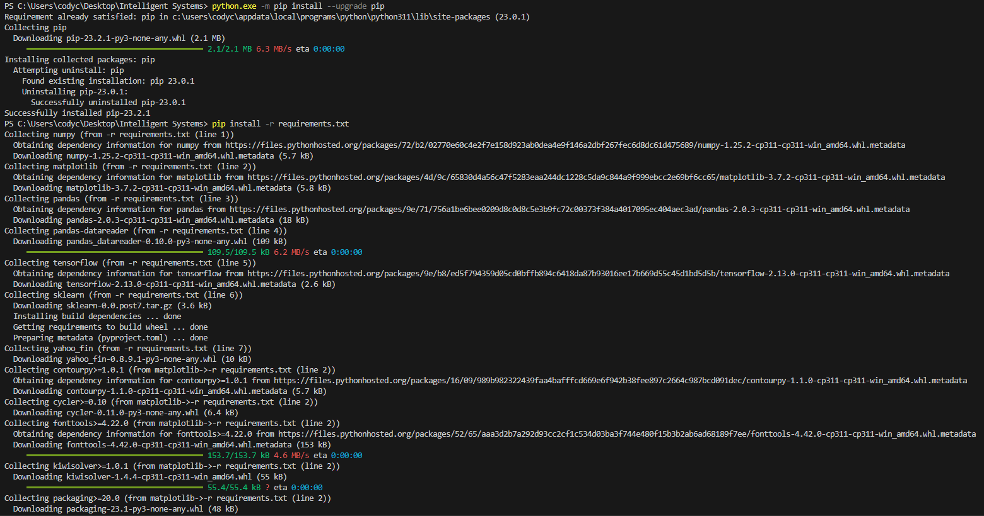

After first updating pip, the libraries installed successfully. Despite this, the code was still showing the same errors for all the libraries.

After reloading and making sure the workspace and code file were trusted, most of the issues resolved themselves. A few of the libraries (like yfinace) were still showing errors because I didn’t have them added to requirements, so I updated and re-ran the requirements file.

This fixed all the imports except the bottom 2. Both “from tensorflow.keras…” were still showing issues however the code seemed to be able to run. I looked around for fixes but couldn’t find any so for now I’ll leave it as is and come back if it causes problems.

After running the code, it completed 25 steps of epoch in the console, then produced this graph and a prediction value. At this point I’ve completed up to step 4 of this task.



The graph shows predicted prices, with one day predicted price being generated from 60 days of existing data. The prices being predicted in this graph are in the past, so we already have real data to compare with, which is also shown on the graph. This allows us to check the accuracy of the prediction.

The single prediction value shown in the console is an actual future prediction on data we do not have yet.